Assignment 1: ETL Process Report

1. Data Issues Found and Cleaning Actions Taken
- Issue: The dataset had the potential to contain identical duplicate rows.
  - Action: The Duplicate Row Filter node was used to scan and remove any exact duplicates, ensuring each record was unique.
- Issue: Column names were not standardized, using spaces and mixed capitalization.
  - Action: The Column Rename node was applied to change some headers to a consistent snake cases format (eg: first_name).
- Issue: Some records had missing (null) values in the "Website" column.
  - Action: The Missing Value node was used to find these blank cells and fill them with the string "N/A" to make the dataset complete.

2. Transformation Steps Applied
After cleaning, the data was transformed to add value and prepare it for analysis:
- Feature Engineering: A new full_name column was created by joining the first name and last name columns using the String Manipulation node.
- Date Extraction: The Extract Date&Time Format Extract node was used on the subscription date column to create new columns foryear, month and day.
- Filtering & Aggregation:
  - A Row Filter node was used to create a separate table of just customers from the “Canada".
  - A GroupBy node was used on the main dataset to count the total number of customers from each country

3. Summary of Findings
The aggregated data from the GroupBy node was sent to the Bar Chart node to create a visualization.
As the chart 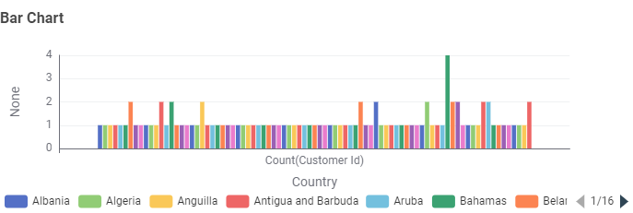shows, the customer base is not evenly distributed. Bahamas has the highest customer count.

